# Kate Waters Consultants

by https://www.craiyon.com/

DriverPass

**CS-255 Project 2 System Design Document**

version 1.0

**Executive Summary**

The development team at, “Kate Waters,” request consultation on the system to be used by DriverPass in their day to day operations. We aim to add value to their business process by adding a layer of automation and telemetry to help them grow and improve their quality of service through the use of Microsoft 365 for Business and their digital commerce products.

**Requirements**

DriverPass will be able to work with their clients online and offline with the various tools provided through Microsoft. Lesson sales and booking is automated through a web portal. Customers who call or walk into their driving school can be registered and have a lesson bought and booked through and employee via the same web portal.

Instructors will have access to their assignments; and system administrators can manage any unusual occurrences as needed. Furthermore, various connectivity between users, DriverPass, and the DMV can also be negotiated using email addresses with the business’ domain name.

**Design Constraints**

We will be working with the staffs personal devices in some cases, preexisting windows machines, and the possibility of non-windows platforms. We will work within Microsoft’s specifications for cross-platform interoperability.

**System Architecture View**

We use Microsoft azure services to get the website up and running. We see what kind of interoperability we can get with their commerce solutions and then connect those to any Microsoft 365 for Small Business solution that makes sense for the client at the time.

**Note:** As of 2/16/2024 the client is interested in Microsoft booking platform and excel, enterprise side. On the Azure end, they’d like to find out what we can do with Zelle and/or Venmo for payments. **EDR**

**Domain Model**

We have provided a series of UML diagrams to describe the system.

* **Figure 1:** We lead with a Use case model that maps all parties involved with the system. The Microsoft platform acts as a service mesh that we draw from to realize the client’s requirements through any constraint or revision or expansion.
* **Figure 2:** The website sequence diagram maps the various series of events that take place between the client and the business.
* **Figure 3:** The Enterprise sequence diagram outlines between the web interface and the enterprise environment.
* **Figure 4:** The Activity diagram for web services shows you what you can do with the system. It highlights each level of automation within the system
* **Figure 5:** The Business 365 activity model explains what employees have access to and the applications they can access and use in their day to day.
* **Figure 6:** The class diagram shows us a power BI flow

## UML Use Case Diagram

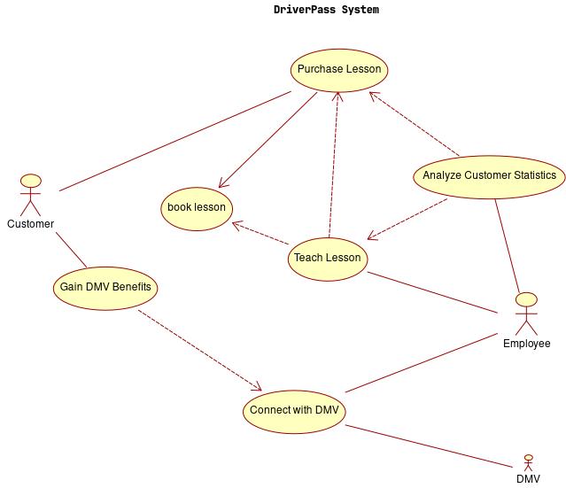Figure 1: Use Case Diagram

### UML Sequence Diagrams

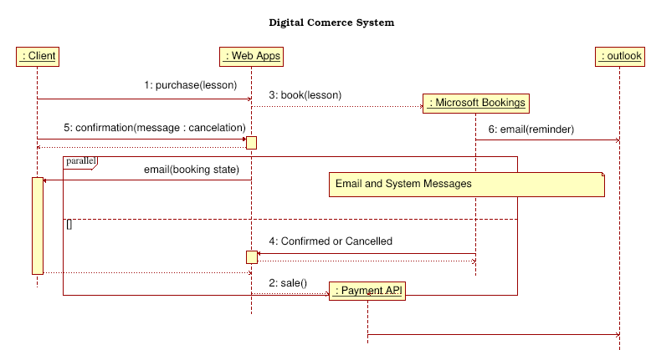Figure 2: Website Sequence Diagram

Qt SVG Document
Generated with QtFigure 3: Enterprise Sequence Diagram

### UML Activity Diagram

Qt SVG Document
Generated with QtFigure 4: Web-services Activity Diagram

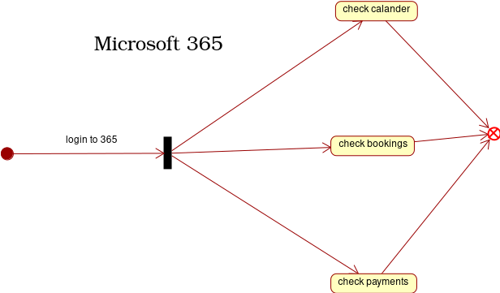Figure 5: Microsoft 365 Activity

### UML Class Diagram

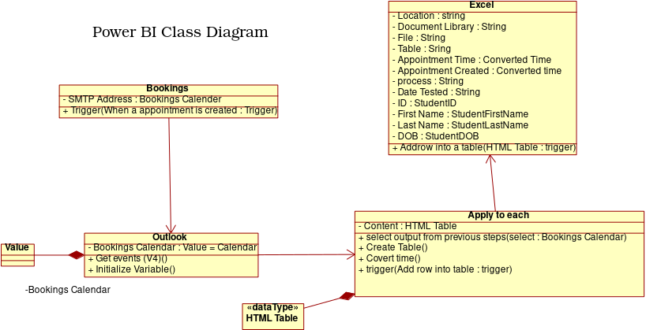Figure 6: power BI flow

## Technical Requirements

*We need to contact or contract a consultant for 365 and digital commerce solutions for some guidance. Anything done with power bi will be purely research until further notice.*